1. **Agenda**:
   1. We will look at the callback Kafka Producer from the Java API.
2. 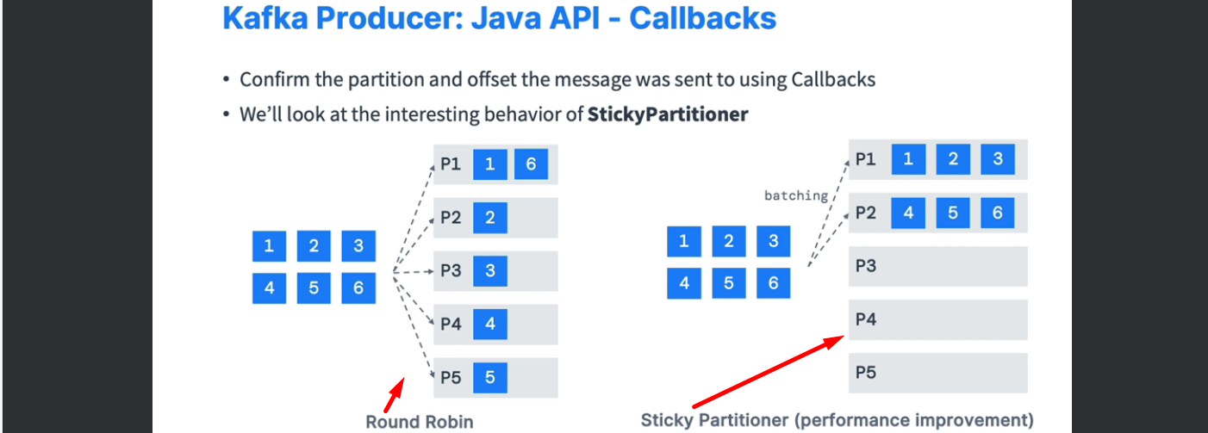
3. Implementing Callback.  
   A screenshot of a computer code

   Description automatically generated  
   When you can run the code and produce msgs, the msgs will be produced to different partitions each time randomly (We have 3 partitions for a topic).

  
  
  
  
  
Continue.

1. Let’s produce multiple msgs to a topic and see the behavior.   
   A screen shot of a computer

   Description automatically generated  
     
   A close-up of a computer screen

   Description automatically generatedA white background with red text

   Description automatically generated  
   A screenshot of a computer

   Description automatically generated
2. 